

Dr. Jason, Morton inc.

2019-12-13

Dr. Morton

86999 Robert Club, South Wendyshire, IL 93746

Phone: 5603790754

Fax: 7131455444

**Re:** Sabrina, Johnson

**PHN:** 3627382911

**Birthdate:** 13-Nov-1980

**Address:** 31042 Chelsea Haven, Lake Kimberlyport, AS 40448

**Patient number:** 9438864551

To Whom It May Concern:

This is a medical letter to state the above patient is pregnant with expected delivery date of 16-Mar-2025. Hoping this information is satisfactory for your requirements.

Thank you.

Sincerely,

Dr. Jason, Morton

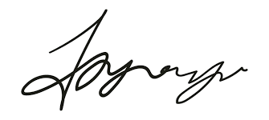

FRCS© NCMP

Clinical Assistant Professor, UBC

Department of Obstetrics and Gynecology SMH